Youth Basketball League Management System:
A Relational Database Design Proposal

Khan Wasi, ADD NAME, ADD NAME

CPSC 332
California State University, Fullerton
Professor Ken Wuttisasiwat
03-26-2026

Abstract
This proposal outlines the design of the Youth Basketball League Management System (YBLMS), a relational database intended to modernize the administrative and operational workflows of a competitive youth basketball organization. The proposed system centralizes the management of players, teams, coaches, guardians, seasons, games, referees, facilities, registrations, and payment records within a single, normalized relational schema. The high-level entity-relationship model presented herein identifies ten primary tables — including two M:N junction tables and two lookup reference tables — along with eleven business rules and constraints that govern data integrity. YBLMS is designed to replace fragmented, spreadsheet-based processes with a scalable, maintainable database architecture suitable for organizations managing dozens of teams and hundreds of players across multiple seasons.

Keywords: relational database, youth sports, entity-relationship model, registration system, scheduling

Youth Basketball League Management System:
A Relational Database Design Proposal
System Description
The Youth Basketball League Management System (YBLMS) is a proposed relational database designed to support the full administrative lifecycle of a competitive youth basketball organization. Many youth leagues currently rely on a patchwork of spreadsheets, paper forms, and standalone payment platforms — a workflow that introduces data redundancy, scheduling errors, and accountability gaps. YBLMS consolidates all operational data into a single normalized relational schema, providing league administrators, coaches, guardians, and referees with a consistent and reliable source of truth. The system is intended for use by small to mid-sized youth basketball organizations that manage multiple teams, divisions, and seasonal rotations simultaneously.
The primary stakeholders of YBLMS include league administrators who configure seasonal operations and oversee the system as a whole; coaches who are assigned to one or more teams and need access to roster information; guardians who register their children, pay participation fees, and receive scheduling updates; and referees who are assigned to games based on availability and certification level. The system tracks player demographics and age-based eligibility, team composition, multi-season coaching assignments, game scheduling across physical gym locations, referee assignments, registration workflows, and payment transaction history. By capturing these interdependencies within a structured relational model, YBLMS enables the enforcement of complex business rules, supports historical reporting, and scales naturally as the organization grows.
Scope

The following items define the functional boundaries of the Youth Basketball League Management System. Each statement describes a specific capability the system is designed to support:
· The system will track player demographics, eligibility status, and guardian contact information for every registered participant.
· The system will manage team rosters, including player assignments that are scoped to a specific season to preserve historical records.
· The system will record and enforce multi-season coaching assignments, supporting scenarios where a single coach manages more than one team.
· The system will schedule games between teams, capturing gym location, date, start time, and final score outcomes.
· The system will assign one or more certified referees to each scheduled game and maintain a log of referee participation history.
· The system will track gym availability and prevent the double-booking of a facility at the same date and time.
· The system will manage guardian-initiated player registrations, including status tracking (Active, Waitlisted, or Withdrawn) throughout the season.
· The system will record payment transactions associated with each registration, supporting statuses of Pending, Completed, and Refunded.
· The system will support multiple seasons with full historical data retention, enabling year-over-year reporting on teams, players, and league performance.
· The system will enforce referential integrity across all related entities, ensuring that no orphaned records exist for payments, registrations, or game assignments.

UML Overview (High-Level Entity-Relationship Model)
The following section provides a high-level description of the entities, attributes, and relationships that constitute the YBLMS relational schema. A visual ER diagram has been prepared using dbdiagram.io and is submitted as a supplementary artifact alongside this proposal.
Entities and Representative Attributes
Table 1
Entity | Type | Key Attributes
Player | Core | player_id (PK), first_name, last_name, date_of_birth, guardian_id (FK)
Guardian | Core | guardian_id (PK), first_name, last_name, email (unique), phone
Team | Core | team_id (PK), team_name, division, season_id (FK)
Coach | Core | coach_id (PK), first_name, last_name, email (unique), phone
Game | Core | game_id (PK), home_team_id (FK), away_team_id (FK), gym_id (FK), game_date, game_time
Referee | Core | referee_id (PK), first_name, last_name, email (unique), certification_level
Season | Core | season_id (PK), season_name, start_date, end_date
Gym | Core | gym_id (PK), gym_name, address, city, capacity
Registration | Junction | registration_id (PK), player_id (FK), team_id (FK), season_id (FK), reg_date, status_id (FK)
GameReferee | Junction | game_id (FK), referee_id (FK) — composite PK
PaymentStatus | Lookup | status_id (PK), status_name {Pending, Completed, Refunded}
RegistrationStatus | Lookup | status_id (PK), status_name {Active, Waitlisted, Withdrawn}

Relationships and Cardinality
Table 2
Relationship | Cardinality | Notes
Guardian → Player | 1 : N | One guardian may register multiple players.
Season → Team | 1 : N | A season contains many teams.
Team → Game (as home/away) | 1 : N | A team participates in many games per season.
Gym → Game | 1 : N | A gym hosts many games; each game uses one gym.
Season → Game | 1 : N | All games belong to a single season.
Registration → Payment | 1 : N | One registration may have multiple payment records.
Player ↔ Team (via Registration) | M : N | A player joins one team per season; Registration is the junction table.
Game ↔ Referee (via GameReferee) | M : N | A game has multiple referees; GameReferee is the junction table.
Coach ↔ Team (via CoachTeam) | M : N | A coach may manage multiple teams and vice versa.

The system includes a minimum of two M:N relationships. The Registration table serves as the junction between Player, Team, and Season — capturing the fact that a player's team membership is seasonal and historically preserved. The GameReferee table resolves the M:N relationship between Game and Referee, allowing each game to have multiple officiating staff while tracking each referee's assignment history across all games in a season.
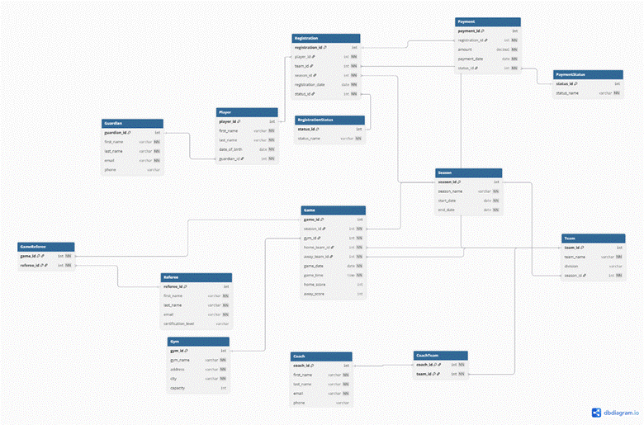
dbdiagram.io for the UML OVERVIEW

Business Rules and Constraints
The following eleven constraints define the logical and referential integrity requirements that YBLMS must enforce. These rules will be implemented through primary keys, foreign keys, unique constraints, check constraints, and application-layer validation logic in subsequent phases of this project.
01: Guardian Email Uniqueness
The email field in the Guardian table must be unique. No two guardians may share the same email address, as email serves as the primary login and communication identifier.
02: Coach Email Uniqueness
The email field in the Coach table must be unique across all coach records, ensuring unambiguous identification of each coaching staff member.
03: Seasonal Team Membership
A player may be registered to only one team per season. The Registration table enforces a composite unique constraint on (player_id, season_id) to prevent duplicate team assignments within the same seasonal period.
04: Season Date Validity
A season's end_date must be strictly greater than its start_date. This constraint prevents the creation of invalid or zero-length seasons.

05: Game Date Within Season
A game's game_date must fall on or between the start_date and end_date of its associated season. Games cannot be scheduled outside of the active seasonal window.
06: No Gym Double-Booking
No two games may be scheduled at the same gym_id with the same game_date and game_time. A composite unique constraint on (gym_id, game_date, game_time) in the Game table enforces this restriction.
07: Self-Play Prevention
A game's home_team_id and away_team_id must reference two distinct teams. A team cannot be scheduled to play against itself.
08: Payment Referential Integrity
A payment record cannot exist without a corresponding, valid registration. The payment_id foreign key references registration_id, and cascading delete or restrict behavior will be defined in Phase 2.
09: Payment Status Constraint
The payment_status field must be one of the predefined values in the PaymentStatus lookup table: Pending, Completed, or Refunded. Direct string insertion outside of these values is not permitted.

10: Registration Status Constraint
The registration_status field must reference a valid value in the RegistrationStatus lookup table: Active, Waitlisted, or Withdrawn.
11: Referee Game Assignment
Every scheduled game must have at least one referee assignment recorded in the GameReferee table before the game's status can be set to Confirmed. This rule is enforced at the application layer during the scheduling workflow.

References
Elmasri, R., & Navathe, S. B. (2016). Fundamentals of database systems (7th ed.). Addison-Wesley.
Wuttisasiwat, K. (2026). CPSC 332: Database — lecture slides. Canvas. California State University, Fullerton.
dbdiagram.io. (2024). Free database diagram (ERD) tool. https://dbdiagram.io

